Generics
- Some bugs are easier to detect than others. Compile-time bugs, for example, can be detected early on; you can use the compiler's error messages to figure out what the problem is and fix it, right then and there.
- Runtime bugs, however, can be much more problematic; they don't always surface immediately, and when they do, it may be at a point in the program that is far removed from the actual cause of the problem.
- Generics, introduced in Java SE 5.0, add stability to your code by making more of your bugs detectable at compile time.

Code that uses generics has many benefits over non-generic code:

Stronger type checks at compile time.
A Java compiler applies strong type checking to generic code and issues errors if the code violates type safety. Fixing compile-time errors is easier than fixing runtime errors, which can be difficult to find.

Elimination of casts.
The following code snippet without generics requires casting:
List list = new ArrayList();
list.add("hello");
String s = (String) list.get(o);

When re-written to use generics, the code does not require casting:
List<String> list = new ArrayList<String>();
list.add("hello");
list.add(new Integer(20));
String s = list.get(0); // no cast

Generic Types: A generic type is a generic class or interface that is parameterized over types.

The following Box class will be modified to demonstrate the concept.

A Simple Box Class
Begin by examining a non-generic Box class that operates on objects of any type. It needs only to provide two methods: set, which adds an object to the box, and get, which retrieves it:
public class Box
{
private Object object;
public void set(Object object)
{
this.object = object;
}
public Object get()
{
return object;
}
}

- Since its methods accept or return an Object, you are free to pass in whatever you want, provided that it is not one of the primitive types.
- There is no way to verify, at compile time, how the class is used.
- One part of the code may place an Integer in the box and expect to get Integers out of it, while another part of the code may mistakenly pass in a String, resulting in a runtime error.

A Generic Version of the Box Class

A generic class is defined with the following format:
class name<T1, T2, ..., Tn>
{
/* ... */
}
The type parameter section, delimited by angle brackets (<>), follows the class name.
It specifies the type parameters(also called type variables) T1, T2, ..., and Tn.

To update the Box class to use generics, you create a generic type declaration by changing the code "public class Box" to "public class Box<T>".
This introduces the type variable, T, that can be used anywhere inside the class.

With this change, the Box class becomes:
/**
* Generic version of the Box class.
* @param <T> the type of the value being boxed
*/
public class Box<T>
{
// T stands for "Type"
private T t;

public void set(T t)
{
this.t = t;
}
public T get()
{
return t;
}
}

As you can see, all occurrences of Object are replaced by T.
A type variable can be any non-primitive type you specify: any class type, any interface type, any array type, or even another type variable.
This same technique can be applied to create generic interfaces.

Multiple Type Parameters:
As mentioned previously, a generic class can have multiple type parameters. For example, the generic OrderedPairclass, which implements the generic Pair interface:

public interface Pair<K, V>
{
public K getKey();
public V getValue();
}
public class OrderedPair<K, V> implements Pair<K, V>
{
private K key;
private V value;
public OrderedPair(K key, V value)
{
this.key = key;
this.value = value;
}
public K getKey()
{
return key;
}
public V getValue()
{
return value;
}
}

The following statements create two instantiations of the OrderedPair class:
Pair<String, Integer> p1 = new OrderedPair<String, Integer>("Even", 8);
Pair<String, String> p2 = new OrderedPair<String, String>("hello", "world");

Unchecked Error Messages:
As mentioned previously, when mixing legacy code with generic code, you may encounter warning messages similar to the following:
Note: Example.java uses unchecked or unsafe operations.
Note: Recompile with -Xlint: unchecked for details.

import java.util.Iterator;
import java.util.LinkedList;
import java.util.List;
public class LinkedListTest
{
public static void main(String[] args)
{
List b = new LinkedList();
b.add("Bob");
b.add("Doug");
b.add("Frances");
b.add("Gloria");
System.out.println(b);
}
}

Generic Methods:
- Generic methods are methods that introduce their own type parameters.
- This is similar to declaring a generic type, but the type parameter's scope is limited to the method where it is declared.
- Static and non-static generic methods are allowed, as well as generic class constructors.
- The syntax for a generic method includes a type parameter, inside angle brackets, and appears before the method's return type.
- For static generic methods, the type parameter section must appear before the method's return type.

The Utils class includes a generic method, compare, which compares two Pair objects:

class Utils
{
public static <K, V> boolean compare(Pair<K, V> p1, Pair<K, V> p2)
{
return p1.getKey().equals(p2.getKey()) && p1.getValue().equals(p2.getValue());
}
}

public class Pair<K, V>
{
private K key;
private V value;

// Generic constructor
public Pair(K key, V value)
{
this.key = key;
this.value = value;
}

// Generic methods
public void setKey(K key)
{
this.key = key;
}
public void setValue(V value)
{
this.value = value;
}
public K getKey()
{
return key;
}
public V getValue()
{
return value;
}
public static void main(String args[])
{
Pair<Integer, String> p1 = new Pair<Integer,String>(1, "apple");
Pair<Integer, String> p2 = new Pair<Integer,String>(2, "pear");
boolean same = Utils.<Integer, String>compare(p1, p2);
if(same)
System.out.println("matched");
else
System.out.println("not matched");
}
}

Bounded Type Parameters:
- There may be times when you want to restrict the types that can be used as type arguments in a parameterized type.
- For example, a method that operates on numbers might only want to accept instances of Number or its subclasses.
- This is what bounded type parameters are for.
- To declare a bounded type parameter, list the type parameter's name, followed by the extends keyword, followed by its upper bound, which in this example is Number.
- Note that, in this context, extends is used in a general sense to mean either "extends" (as in classes) or "implements" (as in interfaces).
public class Boxs<T>
{
private T t;
public void set(T t)
{
this.t = t;
}
public T get()
{
return t;
}
public <U extends Number> void inspect(U u)
{
System.out.println("U: " + u.getClass().getName());
}

public static void main(String[] args)
{
Boxs<Integer> integerBox = new Boxs<Integer>();
integerBox.set(new Integer(10));
integerBox.inspect(10);
//integerBox.inspect("some text");
}
}
Collections in Java
Collections: Data structure that holds objects and provides various utility methods to manage the data.

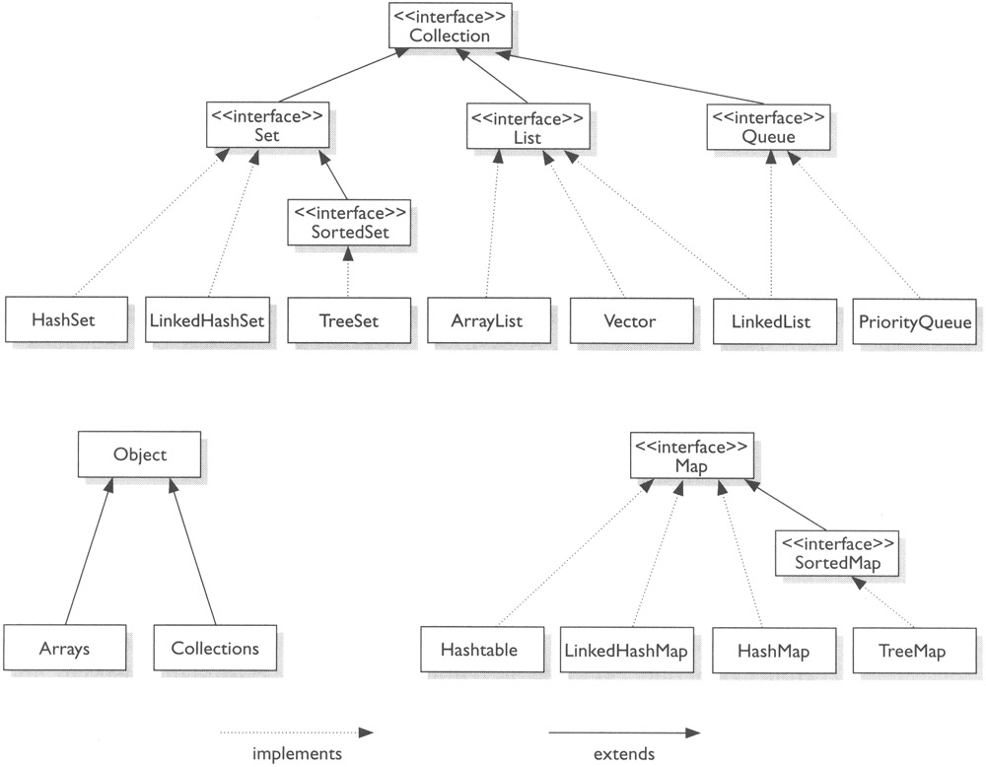

We have discussed already about arrays

Difference between Arrays and Collections:

Arrays:
- They are fixed in size.
- With respect to memory arrays are not preferable
- Arrays shows very good Performance
- Can hold only homogeneous data elements.
- Arrays can hold both primitive data types and objects
- They do not have any underlying data structures.

class Example
{
public static void main(String[] args)
{
int arr[]=new int[8];
arr[0]=10;
arr[1]=20;
Integer a=30;//auto boxing
arr[2]=a;
for(int i=0;i<3;i++)
{
System.out.println(arr[i]);
}
}
}

Cannot hold heterogeneous data:
class Example
{
public static void main(String[] args)
{
int arr[]=new int[8];
arr[0]=10;
arr[1]=20.5;
Integer a=30;//auto boxing
arr[2]=a;
for(int i=0;i<3;i++)
{
System.out.println(arr[i]);
}
}
}

Collections:
- Growable in nature.
- With respect to memory collections are recommended.
- It shows poor Performance.
- Can hold both homogeneous and Heterogeneous.
- They have underlying data structure.
- Collections hold only Objects.

The Collections Framework consists of three parts

• Interfaces (abstract data types).
• Implementations, the concrete versions of these interfaces.
• Algorithms (functionalities), the predefined actions that can be defined on either the interfaces or their implementations.
• All implementations are Serializable and cloneable
• All implementations support having null elements.

Framework Interfaces

The framework consists of four core interfaces with two specializations for sorting
- Collection
- List
- Set
- Map
- SortedSet
- SortedMap
- Queue

Collection interface:

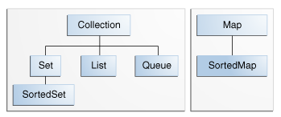
Table of the ordered and unordered Collection interfaces shown as:
Interface name | Ordered | Allows duplicates
Collection | No | Yes
Set | No | No
List | Yes | Yes
Map | No | No
SortedSet | Yes | No
SortedMap | Yes | No

public interface Collection

- The root interface in the collection hierarchy.
- A collection represents a group of objects, known as its elements.
- Some collections allow duplicate elements and others do not.
- Some are ordered and others unordered.
- The SDK(sun jdk) does not provide any direct implementations of this interface: it provides implementations of more specific sub interfaces like Set and List.
- All general-purpose Collection implementation classes (which typically implement Collection indirectly through one of its sub interfaces) should provide two "standard" constructors:
  - A void (no arguments) constructor, which creates an empty collection,
  - A constructor with a single argument of type Collection, which creates a new collection with the same elements as its argument.

public interface Collection<E>..
- The <E> syntax tells that, the declared interface is a generic interface i.e. when you declare a Collection instance you should specify the type of object contained in the collection.
- This interface supports basic operations like adding and removing.
- When you try to remove an element, only a single instance of the element in the collection is removed, if it is available.
- Following methods can be used for adding and deleting an element respectively.
boolean add(Object element)
boolean remove(Object element)

The list of other methods belonging to the Collection interface is shown in the table given below
Method | Uses
add(E o) | Adds the specified element to this set if it is not already present (optional operation).
clear() | Removes all of the elements from this set (optional operation).
contains(Object o) | Returns true if this set contains the specified element.
equals(Object o) | Compares the specified object with this set for equality.
hashCode() | Returns the hash code value for this set.
isEmpty() | Returns true if this set contains no elements.
remove(Object o) | Removes the specified element from this set if it is present (optional operation).
size() | Returns the number of elements in this set (its cardinality).

Implementations of the Collection interface normally have a constructor that accepts a Collection object. This enables you to convert a Collection to a different type of Collection, such as a Queue to a List, or a List to a Set, etc. Here are the constructors of some implementations:

public ArrayList (Collection c)
public HashSet (Collection c)
public LinkedList (Collection c)

Following code converts a Queue to a List.
import java.util.ArrayList;
import java.util.LinkedList;
import java.util.List;
import java.util.Queue;
public class MainClass {
public static void main(String[] args) {
Queue queue = new LinkedList();
queue.add("Hello");
queue.add("World");
List list = new ArrayList(queue);
System.out.println(list);
}
}

Converts a List to a Set:
import java.util.ArrayList;
import java.util.HashSet;
import java.util.List;
import java.util.Set;
public class MainClass
{
public static void main(String[] args)
{
List myList = new ArrayList();
myList.add("Hello");
myList.add("World");
myList.add("World");
myList.add("Hai");
System.out.println(myList);
Set set = new HashSet(myList);
System.out.println(set);
}
}

Difference ArrayList and Array in Java

- The ArrayList class implements the List interface.
- ArrayList supports dynamic arrays that can grow as needed.
- In Java, standard arrays are of a fixed length.
- After arrays are created, they cannot grow or shrink, which means that you must know in advance how many elements an array will hold.
- But, sometimes, you may not know until run time precisely how large of an array you need.
- To handle this situation, the collections framework defines ArrayList.
- In essence, an ArrayList is a variable-length array of object references.
- That is, an ArrayList can dynamically increase or decrease in size.
- Array lists are created with an initial size. When this size is exceeded, the collection is automatically enlarged.
- When objects are removed, the array may be shrunk.

ArrayList has the constructors shown here:
ArrayList( )
ArrayList(Collection c)
ArrayList(int capacity)

- The first constructor builds an empty array list.
- The second constructor builds an array list that is initialized with the elements of the collection c.
- The third constructor builds an array list that has the specified initial capacity.
- The capacity is the size of the underlying array that is used to store the elements.
- The capacity grows automatically as elements are added to an array list.

// add() -- method will add element in refered index position, the value there in current index position will be pushed to the next indexes.
// where as set() -- method will replace the value at the refered index position.

import java.util.*;
class ArrayListDemo
{
public static void main(String args[])
{
ArrayList al = new ArrayList(5);
System.out.println("Initial size of al: " +al.size());
al.add("C");
al.add("A");
al.add("E");
al.add("B");
al.add("D");
al.add("F");
al.add(1, "A2");
al.add(“F”);
System.out.println("Size of al after additions: " + al.size());
System.out.println("Contents of al: " + al);
al.remove("F");
al.remove(2);
System.out.println("Size of al after deletions: " + al.size());
System.out.println("Contents of al: " + al);
}
}

import java.util.ArrayList;
public class MainClass
{
public static void main(String[] args)
{
ArrayList myList = new ArrayList(5);
for (int i = 0; i < 5; i++)
{
myList.add(new Integer(i));
}
System.out.println("List contains " + myList.size() + " elements");
Integer int2 = new Integer(2);
System.out.println("List contains Integer(2): " + myList.contains(int2));
System.out.println("Integer(2) is at index " + myList.indexOf(int2));
myList.set(2, new Integer(99));
System.out.println("Get element at index 2: " + myList.get(2));

}
}
//indexOf() is a method which checks for the index position of a given element
//contains() method will be checking whether given element to it is available in the list or not.
//it throws a Boolean value true if the element exists in the list. Or returns false if the element doesn’t exists in the list.
// get() method will be retrieving the value there at mentioned index position

import java.util.ArrayList;
public class ArrayListDemo1
{
public static void main(String args[])
{
ArrayList<Integer> arrlist = new ArrayList<Integer>(5);
arrlist.add(35);
arrlist.add(20);
arrlist.add(25);

arrlist.trimToSize();
for (Integer number : arrlist)
{
System.out.println("Number = " + number);
}
}
}

Although the capacity of an ArrayList object increases automatically as objects are stored in it, you can increase the capacity of an ArrayList object manually by calling ensureCapacity( ).

The signature for ensureCapacity( ) is shown here:
void ensureCapacity(int cap)

import java.util.ArrayList;

public class ArrayListDemo {
public static void main(String args[]) {
ArrayList<Integer> arrlist = new ArrayList<Integer>(5);
System.out.println("List contains " + arrlist.size() + " elements");
arrlist.add(10);
arrlist.add(50);
arrlist.add(30);
arrlist.ensureCapacity(15);
for (Integer number : arrlist) {
System.out.println("Number = " + number);
}
System.out.println("List contains " + arrlist.size() + " elements");

}
}

We cannot check the size directly;

import java.util.ArrayList;
public class GetSizeOfArrayListExample
{
public static void main(String[] args)
{
ArrayList<String> arrayList = new ArrayList<String>();
arrayList.add("1");
arrayList.add("2");
arrayList.add("3");
int totalElements = arrayList.size();
System.out.println("ArrayList contains...");
for(int index=0; index < totalElements; index++)
System.out.println(arrayList.get(index));
arrayList.ensureCapacity(15);
int newsize=arrayList.size();
System.out.println("new size is :"+newsize);

}
}

Use the Iterator:
Method Summary
boolean | hasNext() Returns true if the iteration has more elements.
Object | next() Returns the next element in the iteration.

import java.util.ArrayList;
import java.util.Iterator;

public class MainClass
{
public static void main(String[] a)
{
ArrayList<String> nums = new ArrayList<String>();
nums.add("O");
nums.add("Two");
nums.add("Three");
nums.add("Four");

String s;
Iterator e = nums.iterator();
while (e.hasNext())
{
s = (String) e.next();
System.out.println(s);
}
}
}

To clear all objects:
import java.util.ArrayList;
import java.util.List;
public class Main {
public static void main(String args[]) throws Exception {
List<String> list = new ArrayList<String>();
list.add("A");
list.add("B");
list.add("C");
list.clear();
System.out.println(list);
}
}

To check two lists are equal or not.

import java.util.Arrays;
import java.util.List;

public class Main {

public static void main(String[] a) {

List list = Arrays.asList(new String[] { "A", "B", "C", "D" });
List list2 = Arrays.asList(new String[] { "A", "B", "C" });
System.out.println(list.equals(list2));
}
}

To check list is empty or not:
import java.util.Arrays;
import java.util.List;
public class Main {
public static void main(String[] a) {
List list = Arrays.asList(new String[] { "A", "B", "C", "D" });
System.out.println(list.size());
System.out.println(list.isEmpty());
}
}

Convert an ArrayList into an array.

import java.util.ArrayList;

class ArrayListToArray
{
public static void main(String args[])
{
int sum = 0;
ArrayList<Integer> al = new ArrayList<Integer>();
al.add(1);
al.add(2);
al.add(3);
al.add(4);
System.out.println("Contents of al: " + al);
/*for (int i : al)
sum += i;
System.out.println("Sum is: " + sum);*/
Integer ia[] = new Integer[al.size()];
ia = al.toArray(ia);
for (int i : ia)
sum += i;
System.out.println("Sum is: " + sum);
}
}

Difference between ArrayList and Vector in Java
- java.util.Vector came along with the first version of java development kit (JDK).
- java.util.ArrayList was introduced in java version1.2, as part of java collections framework.
- All the methods of Vector are synchronized. But, the methods of ArrayList are not synchronized.
- All the new implementations of java collection framework are not synchronized.
- Vector and ArrayList both uses Array internally as data structure.
- They are dynamically resizable. Difference is in the way they are internally resized.
- By default, Vector doubles the size of its array when its size is increased.
- But, ArrayList increases by half of its size when its size is increased.

Vector or ArrayList? Which is better to use in java?
In general, executing a ‘synchronized’ method results in costlier performance than a unsynchronized method. Keeping the difference in mind, using Vector will incur a performance hit than the ArrayList. But, when there is a certain need for thread-safe operation Vector needs to be used.

Is there an alternate available in java for Vector?
ArrayList can be synchronized using the java collections framework utility class and then ArrayList itself can be used in place of Vector.

import java.util.*;
class VectorDemo {
public static void main(String args[]) {
// initial size is 3, increment is 2
Vector v = new Vector(3,2);
System.out.println("Initial size: " + v.size());
System.out.println("Initial capacity: " +v.capacity());
v.addElement(new Integer(1));
v.addElement(new Integer(2));
v.addElement(new Integer(3));
v.addElement(new Integer(4));
System.out.println("Capacity after four additions: " +v.capacity());
v.addElement(new Double(5.45));
System.out.println("Current capacity: " + v.capacity());
v.addElement(new Double(6.08));
v.addElement(new Integer(7));
System.out.println("Current capacity: " + v.capacity());
v.addElement(new Float(9.4));
v.addElement(new Integer(10));
System.out.println("Current capacity: " + v.capacity());
v.addElement(new Integer(11));
v.addElement(new Integer(12));
v.addElement(new Integer(13));
System.out.println("Current capacity: " + v.capacity());
System.out.println("First element: " + (Integer)v.firstElement());
System.out.println("Last element: " + (Integer)v.lastElement());
if(v.contains(new Integer(3)))
System.out.println("Vector contains 3.");
// enumerate the elements in the vector.
Enumeration vEnum = v.elements();
System.out.println("\\nElements in vector:");
while(vEnum.hasMoreElements())
System.out.print(vEnum.nextElement() + " ");
System.out.println();
}
}

To synchronize the array list:
Is there an alternate available in java for Vector?
- ArrayList can be synchronized using the java collections framework utility class and then ArrayList itself can be used in place of Vector.
- When there is no need for synchronized operation and you still look for better performance of ArrayList.
- In the sense of size incremenatation only we can synchronize the array list

import java.util.ArrayList;
import java.util.Collections;
import java.util.List;

public class Main {
public static void main(String[] args) {
ArrayList arrayList = new ArrayList();
List list = Collections.synchronizedList(arrayList);
}
}

import java.util.ArrayList;
import java.util.Collections;
import java.util.List;
public class SynchronizedArrayList
{
public static void main(String[] args)
{
// Create an ArrayList and populate it with elements
ArrayList arrayList = new ArrayList();
arrayList.add("element_1");
arrayList.add("element_2");
arrayList.add("element_3");
// static void synchronizedList(List list) method returns a synchronized list from the provided ArrayList
List syncList = Collections.synchronizedList(arrayList);
System.out.println("syncList conatins : " + syncList);
}
}

To remove the duplicates from arraylist:
import java.util.ArrayList;
import java.util.HashSet;
import java.util.List;

public class Main {
public static void main(String[] argv) {
List<String> arrayList1 = new ArrayList<String>();

arrayList1.add("A");
arrayList1.add("A");
arrayList1.add("B");
arrayList1.add("B");
arrayList1.add("B");
arrayList1.add("C");

HashSet<String> hashSet = new HashSet<String>(arrayList1);

List<String> arrayList2 = new ArrayList<String>(hashSet);

for (Object item : arrayList2)
System.out.println(item);
}
}

LinkedList:
- The LinkedList class extends AbstractSequentialList and implements the List interface.
- It provides a linked-list data structure. It has the two constructors, shown here:
LinkedList( )
LinkedList(Collection c)

- The first constructor builds an empty linked list.
- The second constructor builds a linked list that is initialized with the elements of the collection c.
- In addition to the methods that it inherits, the LinkedList class defines some useful methods of its own for manipulating and accessing lists.
- To add elements to the start of the list, use addFirst( ); to add elements to the end, use addLast( ).
void addFirst(Object obj)
void addLast(Object obj)

- To obtain the first element, call getFirst( ). To retrieve the last element, call getLast( ).
Object getFirst( )
Object getLast( )

- To remove the first element, use removeFirst( ); to remove the last element, call removeLast( ).
Object removeFirst( )
Object removeLast( )

Diagrammatical representation of linkedlist(double) in java:
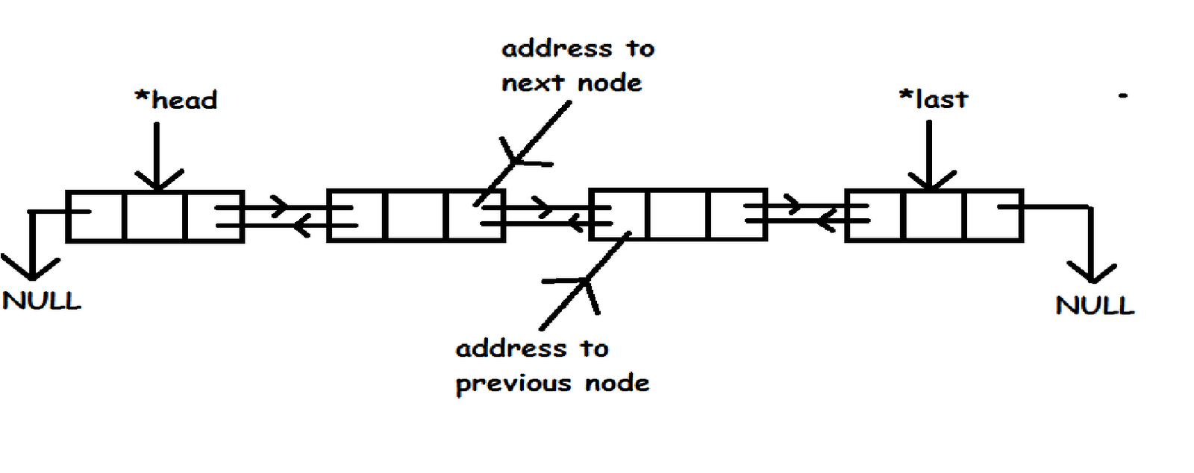

Inserting element in the middle of the linked list:

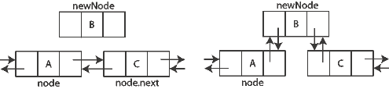

import java.util.LinkedList;
class LinkedListDemo
{
public static void main(String args[])
{
LinkedList ll = new LinkedList();
ll.add("F");
ll.add("B");
ll.add("D");
ll.add("E");
ll.add("C");
ll.addLast("Z");
ll.addFirst("A");
ll.add(1, "A2");
System.out.println("Original contents of ll: " + ll);
ll.remove("F");
ll.remove(2);
System.out.println("Contents of ll after deletion: " + ll);
ll.removeFirst();
ll.removeLast();
System.out.println("ll after deleting first and last: "+ ll);
Object val = ll.get(2);
ll.set(2, (String) val + "-Changed");
System.out.println("ll after change: " + ll);
}
}

Difference between arraylist and linkedlist:
- Since Array is an index based data-structure searching or getting element from Array with index is pretty fast.
- Array provides O(1) performance of get(index) method but remove is costly in ArrayList as you need to rearrange all elements.
- On the Other hand LinkedList doesn't provide Random or index based access and you need to iterate over linked list to retrieve any element which is of order O(n).
- Insertions are easy and fast in LinkedList as compared to ArrayList because there is no risk of resizing array and copying content to new array if array gets full.
- ArrayList also needs to update its index if you insert something anywhere except at the end of array.
- Removal is like insertions better in LinkedList than ArrayList.

- It seems, LinkedList takes a lot of time to create the node objects that wrap the elements.

import java.util.LinkedList;
import java.util.ArrayList;
import java.util.List;
class Test
{
private static Object[] objects;
static
{
objects = new Object[1000000];
for (int i = 0; i < objects.length; i++)
objects[i] = new Object();
}
static void test(List<Object> list)
{
long start = System.currentTimeMillis();
for (Object o: objects)
list.add(o);
System.out.println(System.currentTimeMillis()-start);
}
public static void main(String[] args)
{
test(new ArrayList<Object>());
test(new LinkedList<Object>());
}
}

Linked list occupies more memory than arraylist because it has to allocate memory to store the object as well as to store the reference of another object:
import java.util.LinkedList;
import java.util.ArrayList;
import java.util.List;
class Test
{
private static Object[] objects;
static
{
objects = new Object[2000000];
for (int i = 0; i < objects.length; i++)
objects[i] = new Object();
}
static void test(List<Object> list)
{
long start = System.currentTimeMillis();
for (Object o: objects)
list.add(o);
System.out.println(System.currentTimeMillis()-start);
}
public static void main(String[] args)
{
//test(new ArrayList<Object>());
test(new LinkedList<Object>());
}
}

When to use LinkedList and ArrayList in Java:As I said LinkedList is not as popular as ArrayList but still there are situation where a LinkedList is better choice than ArrayList in Java. Use LinkedList in Java if:

1) Your application can live without Random access. Because if you need nth element in LinkedList you need to first traverse up to nth element O(n) and then you get data from that node.

2) Your application is more insertion and deletion driver and you insert or remove more than retrieval. Since insertion or removal doesn't involve resizing it’s much faster than ArrayList.

Set Interface
- The Set interface extends the Collection interface.
- The Set interface contains only methods inherited from Collection and adds the restriction that duplicate elements are prohibited.
- It neither contains duplicate elements nor maps a key value to an object.
- It permits a single element to be null.
- The Set interface contains only methods inherited from Collection interface, these are shown in the table given below:

Method | Uses
add( ) | Adds an object to the collection
clear( ) | Removes all objects from the collection
contains( ) | Returns true if a specified object is an element within the collection
isEmpty( ) | Returns true if the collection has no elements
remove( ) | Removes a specified object from the collection
size( ) | Returns the number of elements in the collection

- A Set represents a mathematical set.
- It is a Collection that, unlike List, does not allow duplicates.
- There must not be two elements of a Set, say e1 and e2, such that e1.equals(e2).
- The add method of Set returns false if you try to add a duplicate element.

Creating a HashSet
The HashSet class provides four constructors broken into two sets. The first three constructors create empty sets of varying sizes:
public HashSet()
public HashSet(int initialCapacity)
public HashSet(int initialCapacity, int loadFactor)

When creating any collection, it is always best to have the local variable is of the interface type,
Set set = new HashSet()
The fourth constructor acts as a copy constructor.
public HashSet(Collection col)
If the original collection had duplicates, only one of the duplicates will be in the final created set.

Why we implement HashTable type data structures. The reason for that is speed of searching particular element. In hashing we try to search an element in a constant time. And the load factor of Hashtable directly effect to the searching speed

Number of stored elements in the table
Load factor = -------------------------------------------------------------------
Size of the hash table

Load factor:
- So, if the capacity of the HashTable is 20, the objects hashCode will be calculated modulo 20, which always returns a value between 0 and 19 --> The array index.
- You see that the greater the capacity is, the better distributed the values will get. At its best every object has its own index (or bucket).
- This is important because upon object retrieval the HashTable calculates the index, looks it up and finds 0 to n objects placed in that bucket.
- Now it has to iterate over all objects found and use it's equals method to determine the object we look for.
- That is why it's important to have a good distribution among the indexes, because in the worst case (e.g. index is always the same) all objects will land in the same bucket and whenever you want to retrieve an object the HashTable has to iterate over all objects (which is pretty much what LinkedList does).
- The load factor is the amount of load that has to be reached until the capacity is increased to ensure a better distribution.
- Let's say the load factor is 0.75 and we have an initial capacity of 20.
- As soon as the 15th element is added, the capacity is increased (in general doubled) and the elements get redistributed.
- Now that we have 40 instead of 20 buckets available, the elements get distributed better and the object retrieval is fast as a beam of light ;-) ..

In the Java platform, Collections Framework provides three general-purpose Set implementation-classes:

- HashSeT
- LinkedHashSet
- TreeSet

HashSet:
This is a class which stores its elements in a hash table and doesn't allow storing duplicate collections. This class permits the null element and is used to perform the basic operations such as add, remove, contains and size. This is the best way to perform set implementation.

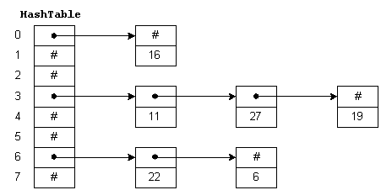

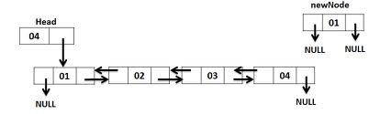

- A hash table is simply an array that is addressed via a hash function.
- For example, HashTable is an array with 8 elements.
- Each element is a pointer to a linked list of numeric data.
- The hash function for this example simply divides the data key by 8, and uses the remainder as an index into the table.
- This yields a number from 0 to 7. Since the range of indices for HashTable is 0 to 7, we are guaranteed that the index is valid.
- To insert a new item in the table, we hash the key to determine which list the item goes on, and then insert the item at the beginning of the list.
- For example, to insert 11, we divide 11 by 8 giving a remainder of 3. Thus, 11 goes on the list starting at HashTable[3].
- To find a number, we hash the number and chain down the correct list to see if it is in the table.
- To delete a number, we find the number and remove the node from the linked list.

TreeSet:
The TreeSet implementation is useful when you need to extract elements from a collection in a sorted manner. The elements added to a TreeSet are sortable in an order. It is generally faster to add elements to a HashSet, then converting the collection to a TreeSet for sorted traversal.

data values  of all nodes in  the left subtree  of node n | < | data value  at node n | < | data values  of all nodes in  the right subtree  of node n

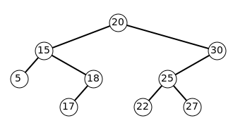

Differences HashSet and TreeSet:
Treeset does not allow heterogenous elements, null insertion is also not possible
HashSet | TreeSet
1. It extends AbstractSet. | 1. It extends AbstractSet and implements SortedSet.
2. It follows hashing mechanism to organize its data. | 2. It follows binary trees (AVL trees) to  organize the data.
3. We cannot determine in which order it displays its data. | 3. It always displays the data in sorted  order.
4. Retrieval time is more. | 4. Retrieval time is less.
5. The operations like insertion, deletion and modifications takes more amount of time. | 5. The operations like insertion, deletion  and modifications take very less time.
6. Creating HashSet is nothing but creating an object of HashSet () class. | 6. Creating TreeSet is nothing but  creating an object of TreeSet () class.

import java.util.HashSet;
import java.util.Set;

public class MainClass {

public static void main(String[] a) {
Set set = new HashSet();
set.add("Hello");
if (set.add("Hello")) {
System.out.println("addition successful");
} else {
System.out.println("addition failed");
}

}
}

Initialize a set without manually adding each element
public static List asList(Object[] a)

import java.util.Arrays;
import java.util.HashSet;
import java.util.Set;
public class MainClass {
public static void main(String[] a) {
String elements[] = { "A", "B", "C", "D", "E" };
Set set = new HashSet(Arrays.asList(elements));
System.out.println(set);
}
}

Remember that set is unordered
Manual adding of elements:
import java.util.Arrays;
import java.util.HashSet;
import java.util.Set;

public class MainClass {

public static void main(String[] a) {
String elements[] = { "A", "B", "C", "D", "E" };
Set set = new HashSet(Arrays.asList(elements));
set.add("Z");
System.out.println(set);
}
}
List is ordered

import java.util.Arrays;
import java.util.HashSet;
import java.util.List;
import java.util.ArrayList;

public class MainClass {

public static void main(String[] a) {
String elements[] = { "A", "B", "C", "D", "E" };
List set = new ArrayList(Arrays.asList(elements));
set.add("W");
System.out.println(set);
}
}

Adding Another Collection with the addAll() method: public boolean addAll(Collection c)

import java.util.Arrays;
import java.util.HashSet;
import java.util.Set;

public class MainClass {

public static void main(String[] a) {
String elements[] = { "A", "B", "C", "D", "E" };
Set set = new HashSet(Arrays.asList(elements));

elements = new String[] { "E", "F" };

set.addAll(Arrays.asList(elements));

System.out.println(set);
}
}

Removing All Elements: public void clear()
import java.util.Arrays;
import java.util.HashSet;
import java.util.Set;

public class MainClass {

public static void main(String[] a) {
String elements[] = { "A", "B", "C", "D", "E" };
Set set = new HashSet(Arrays.asList(elements));
elements = new String[] { "E", "F" };
set.addAll(Arrays.asList(elements));
System.out.println(set);
set.clear();
System.out.println(set);
}
}

Removing Single Elements: public boolean remove(Object element)

/*Determining via the equals() method of the element.
If the element is found, the element is removed and true is returned.
If not found, false is returned.
If removal is not supported, you'll get an UnsupportedOperationException thrown.*/

import java.util.Arrays;
import java.util.HashSet;
import java.util.Set;
public class MainClass {

public static void main(String[] a) {
String elements[] = { "A", "B", "C", "D", "E" };
Set set = new HashSet(Arrays.asList(elements));
set.remove("A");
System.out.println(set);
}
}

import java.util.ArrayList;
import java.util.HashSet;
import java.util.List;
import java.util.Set;
class MainClass
{
public static void main(String[] args)
{
List myList = new ArrayList();
myList.add("Hello");
myList.add(null);
myList.add("null");
myList.add("Hai");
System.out.println(myList);
Set set = new HashSet(myList);
System.out.println(set);
}
}

What is the difference between HashSet & LinkedHashSet?

- The only difference is that the LinkedHashSet maintains the order of the items added to the Set.
- It does this by maintaining a doubly linked list containing the hash and the original order of the items.
- According to Sun, the LinkedHashSet should run nearly as fast as the HashSet.
- A LinkedHashSet is an ordered version of HashSet that maintains a doubly-linked List across all elements.
- Use this class instead of HashSet when you care about the iteration order.
- When you iterate through a HashSet the order is unpredictable, while a LinkedHashSet lets you iterate through the elements in the order in which they were inserted.
- A HashSet is an unsorted, unordered Set. It uses the hashcode of the object being inserted, so the more efficient your hashCode() implementation the better access performance you'll get. Use this class when you want a collection with no duplicates and you don't care about order when you iterate through it.

import java.util.*;
public class Example
{
public static void main(String argv[])
{
HashSet hs = new HashSet();
hs.add("five");
hs.add("two");
hs.add("one");
hs.add("six");
hs.add("one");
System.out.println(hs.size());
Iterator it = hs.iterator();
while(it.hasNext())
{
System.out.println(it.next());
}
}

}

Difference between ArrayList vs HashSet in Java
Here is couple of differences between ArrayList and HashSet in Java:

1) First and most important difference between ArrayList and HashSet is that ArrayList implements List interface while HashSet implements Set interface in Java.

2) Another difference between ArrayList and HashSet is that ArrayList allow duplicates while HashSet doesn't allow duplicates. This is the side effect of fist difference and property of implementing List and Set interface.

3) Third difference between ArrayList and HashSet is that ArrayList is an ordered collection and maintains insertion order of elements while HashSet is an unordered collection and doesn't maintain any order.

4) Fourth difference between HashSet and ArrayList is that its index based you can retrieve object by calling get(index) or remove objects by calling remove(index) while HashSet is completely object based. HashSet also doesn't provide get() method.

Creating Hashtable is nothing but creating an object of Hashtable class.(it is a legacy CFW class)
Legacy(old) collection Framework:
When SUN Micro Systems has developed java, collection framework was known as data structures. Data structures in java were unable to meet industry requirements at that time. Hence data structures of java was reengineered and they have added ‘n’ number of classes and interfaces and in later stages the data structures of java is known as new collection framework.
Interfaces:
We have only one interface, namely java.util.Enumeration. This interface is used for extracting the data from legacy collection framework classes.
Classes:
As a part of legacy collection framework we have the following essential classes: Vector, Stack, Dictionary, Hashtable and properties. Here, Vector and Stack belongs to one dimensional classes whereas Dictionary, Hashtable and Properties belongs to two dimensional classes.
- What is the difference between normal collection framework and legacy collection framework?
Answer: All the classes in the normal collection framework are by default belongs to non synchronized classes whereas all classes in legacy collection framework are by default belongs to synchronized classes

Stack: Stack is the sub-class of Vector class. The basic working principle of Stack is Last In First Out.
Stack API:
Constructors:
1.Stack (); 2.Stack (int size);
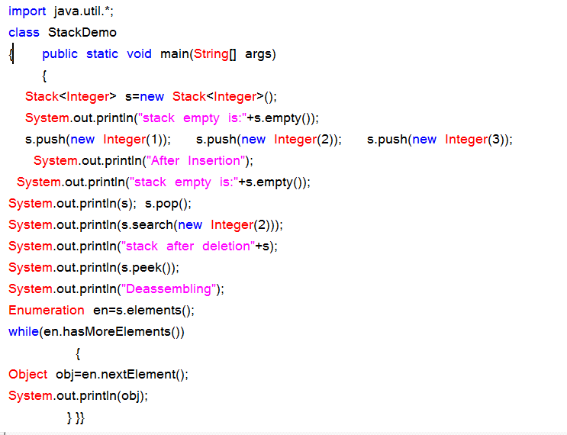
Instance methods:
public boolean empty ();
public void push (Object);
public Object pop ();
public Object peek ();
public int search(Object);
Dictionary:
Dictionary is an abstract class, whose object allows to retrieve to store the data in the form of (key, value) pair. An object of Dictionary never allows duplicate values as key objects and null values.

Hashtable:
Hashtable is the concrete sub-class of Dictionary and where object allows us to store in the form of (key, value) pair. Hashtable object organizes its data by following hashing mechanism. We cannot determine in which order the Hashtable displays its data.
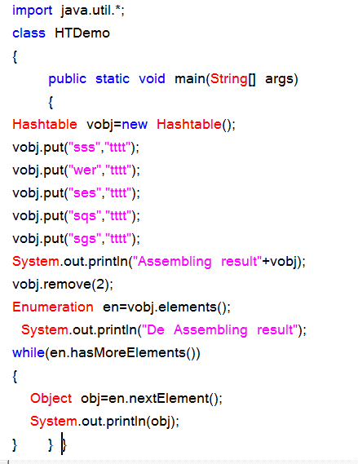
Properties class:
Properties is the sub-class of Hashtable class. Properties class object is used for reading of maintaining system environmental variables and reading the data from resource data file or properties file.
Create a Properties file with My.prop or My.rbf:
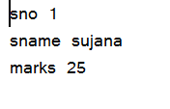

Properties program:
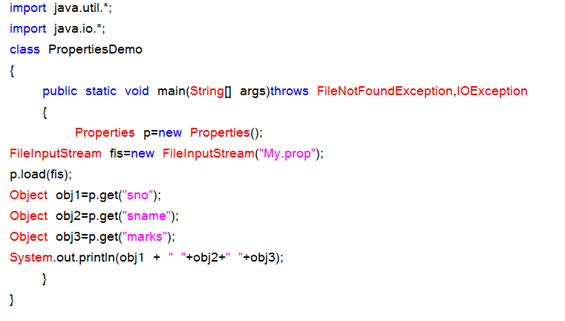
Properties API:
Constructor:
Properties ();
Instance Methods:
public void setProperty (Object kobj, Object vobj);
public Object getProperty (Object kobj);
public void load (InputStream);
Preparation of ResourceBundleFile / Properties file:
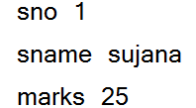
Program on properties file:
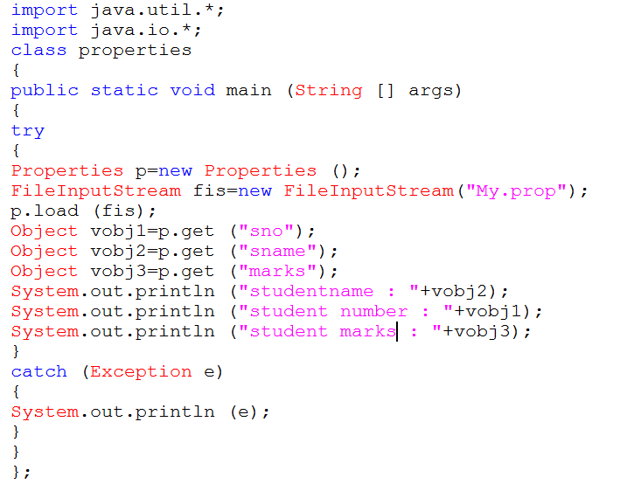
Collections Class:
Collections class is a utility class having static methods for doing operations on objects of classes which implement the Collection interface. For example, Collections has methods for finding the max element in a Collection.
Collections is merely an utility method class for doing certain operations, for example adding thread safety to your ArrayList instance by doing this:
List list = Collections.synchronizedList(new Arraylist());

Source code:
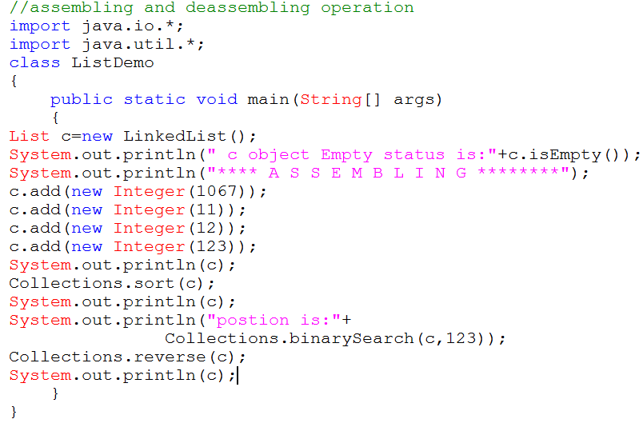
Comparable interface is used to order the objects of user-defined class.This interface is found in java.lang package and contains only one method named compareTo(Object).It provide only single sorting sequence i.e. you can sort the elements on based on single datamember only.For instance it may be either rollno,name,age or anything else.
Syntax:
public int compareTo(Object obj): is used to compare the current object with the specified object.
We can sort the elements of:
- String objects
- Wrapper class objects
- User-defined class objects

This interface present in java.lang package & contains only one method that is "compareTo()".
Method: public int compareTo(Object obj)
obj1.compareTo(Obj2 ) → 1
1) if it returns -ve value obj1 has to come before obj2
2)if it returns +ve value obj1 has to come after obj2
3)if it returns 0 value obj1 , obj2 are equal
Example:
import java.util.*;
class Test
{
public static void main(String args[])
{
System.out.println("A".compareTo("Z"));
System.out.println("Z".compareTo("K"));
System.out.println("A".compareTo("A"));
}
}
Ex:
import java.util.*;
class Test1
{
public static void main(String args[])
{
TreeSet t=new TreeSet();
t.add("Z");
t.add("K");
t.add("D");
t.add("M");
t.add("D");
System.out.println(t); //[ D , K , M , Z ]
}
}
Program:
class Student implements Comparable{
int rollno;
String name;
int age;
Student(int rollno,String name,int age){
this.rollno=rollno;
this.name=name;
this.age=age;
}

public int compareTo(Object obj){
Student st=(Student)obj;
if(age==st.age)
return 0;
else if(age>st.age)
return 1;
else
return -1;
}

}
Simple.java:-
import java.util.*;
import java.io.*;
class Simple
{
public static void main(String args[])
{

ArrayList al=new ArrayList();
al.add(new Student(101,"Vijay",23));
al.add(new Student(106,"Ajay",27));
al.add(new Student(105,"sunil",21));

Collections.sort(al);
Iterator itr=al.iterator();
while(itr.hasNext()){
Student st=(Student)itr.next();
System.out.println(st.rollno+""+st.name+""+st.age);
}
}
}

Public Comparator comparator():-
It returns Comparator object describes underlying Sorting technique.if we used default natural sorting order then we will get null.

Note:
1) The default natural sorting order for the numbers is ascending order
2) The default natural sorting order for characters & strings is
alphabetical order(Dictionary based order)
Note: If we are not satisfied with default natural sorting order.Then we can define
our own customized sorting by using comparator.

- Comparable meant for default Natural sorting order
- Comparator meant for customized sorting order

Collections class provides static methods for sorting the elements of collection. If collection elements are of Set type, we can use TreeSet. But We cannot sort the elements of List. Collections class provides methods for sorting the elements of List type elements.
Method of Collections class for sorting List elements
public void sort(List list): is used to sort the elements of List.List elements must be of Comparable type.
Note: String class and Wrapper classes implements the Comparable interface. So if you store the objects of string or wrapper classes, it will be Comparable.
Example of Sorting the elements of List that contains user-defined class objects on age basis
public void sort(List list,Comparator c): is used to sort the elements of List by the given comparator.

Example of sorting the elements of List that contains user-defined class objects on the basis of age and name.In this example, we have created 4 java classes:
AgeComparator.java,NameComparator.java,Simple.java,Student.java
This class contains three fields rollno, name and age and a parameterized constructor.
Student.java
class Student{
int rollno;
String name;
int age;
Student(int rollno,String name,int age){
this.rollno=rollno;
this.name=name;
this.age=age;
}}
AgeComparator.java:
This class defines comparison logic based on the age. If age of first object is greater than the second, we are returning positive value, it can be any one such as 1, 2 , 10 etc. If age of first object is less than the second object, we are returning negative value, it can be any negative value and if age of both objects are equal, we are returning 0.
Program:
import java.util.*;
class AgeComparator implements Comparator{
public int Compare(Object o1,Object o2){
Student s1=(Student)o1;
Student s2=(Student)o2;
if(s1.age==s2.age)
return 0;
else if(s1.age>s2.age)
return 1;
else
return -1;
}
}
NameComparator.java
This class provides comparison logic based on the name. In such case, we are using the compareTo() method of String class, which internally provides the comparison logic.
Program:
import java.util.*;
class NameComparator implements Comparator{
public int Compare(Object o1,Object o2){
Student s1=(Student)o1;
Student s2=(Student)o2;
return s1.name.compareTo(s2.name);
}
}

Simple.java:In this class, we are printing the objects values by sorting on the basis of name and age.

import java.util.*;
import java.io.*;

class Simple{
public static void main(String args[]){

ArrayList al=new ArrayList();
al.add(new Student(101,"Vijay",23));
al.add(new Student(106,"Ajay",27));
al.add(new Student(105,"Jai",21));

System.out.println("Sorting by Name...");

Collections.sort(al,new NameComparator());
Iterator itr=al.iterator();
while(itr.hasNext()){
Student st=(Student)itr.next();
System.out.println(st.rollno+" "+st.name+" "+st.age);
}

System.out.println("sorting by age...");

Collections.sort(al,new AgeComparator());
Iterator itr2=al.iterator();
while(itr2.hasNext()){
Student st=(Student)itr2.next();
System.out.println(st.rollno+" "+st.name+" "+st.age);
}

}
}
Output: Sorting by Name...
106 Ajay 27
105 Jai 21
101 Vijay 23
Sorting by age...
105 Jai 21
101 Vijay 23
106 Ajay 27

Map interface:
- The Map interface maps unique keys to values. A key is an object that you use to retrieve a value at a later date.
- Given a key and a value, you can store the value in a Map object. After the value is stored, you can retrieve it by using its key.
- Several methods throw a NoSuchElementException when no items exist in the invoking map.
- A ClassCastException is thrown when an object is incompatible with the elements in a map.
- A NullPointerException is thrown if an attempt is made to use a null object and null is not allowed in the map.
- An UnsupportedOperationException is thrown when an attempt is made to change an unmodifiable map.
- The interface methods can be broken down into three sets of operations: altering, querying and providing alternative views.
- The alteration operation allows you to add and remove key-value pairs from the map.
- Both the key and value can be null. However you should not add a Map to itself as a key or value.
Object put(Object key, Object value)
Object remove(Object key)
void putAll(Map t)
void clear()
- The query operations allow you to check on the contents of the map
Object get(Object key)
boolean containsKey(Object key)
boolean containsValue(Object value)
int size()
boolean isEmpty()

- The set methods allow you to work with the group of keys or values as a collection
Set keySet()
Collection values()
Set entrySet()

import java.util.*;
public class CollectionsDemo {
public static void main(String[] args) {
Map m1 = new HashMap();
m1.put(8,"Zara");
m1.put(31,"Mahnaz");
m1.put(12,"Ayan");
m1.put(31,"Daisy");
m1.put(16,null);
m1.put(null,null);
m1.put(8,"ram");
m1.put("8","raju");
System.out.println();
System.out.println(" Map Elements");
System.out.print("\t" + m1);
}
}

TreeMap:

- TreeMap elements are in sorted ordered in term of keys.
- TreeMap doesn’t allow null keys.
- TreeMap allows only similar types of keys

import java.util.*;
public class CollectionsDemo
{
public static void main(String[] args)
{
Map m1 = new TreeMap();
m1.put(8,"Zara");
m1.put(31,"Mahnaz");
m1.put(12,"Ayan");
m1.put(31,"Daisy");
m1.put(16,null);
// m1.put(null,null);
m1.put(8,"ram");
// m1.put("8","raju");
System.out.println();
System.out.println(" Map Elements");
System.out.print("\t" + m1);
}
}

import java.util.*;
class MapDemo
{
public static void main(String args[])
{
String days[]={"Sunday", "Monday", "Tuesday", "Wednesnday","Thursday", "Friday", "Saturday"};
Map map = new HashMap();
try
{
for(int i=0; i<7; i++)
{
map.put(i, days[i]);
}
TreeMap tMap=new TreeMap(map);
//Rerieving all keys
System.out.println("Keys of tree map: " + tMap.keySet());
//Rerieving all values
System.out.println("Values of tree map: " + tMap.values());
//Rerieving the First key and its value
System.out.println("First key: " + tMap.firstKey() +" Value: " + tMap.get(tMap.firstKey()) + "\n");
//Removing the first key and value
System.out.println("Removing first data: " + tMap.remove(tMap.firstKey()));
System.out.println("Now the tree map Keys: " + tMap.keySet());
System.out.println("Now the tree map contain: " + tMap.values() + "\n");
//Rerieving the Last key and value
System.out.println("Last key: " + tMap.lastKey() + " Value: " + tMap.get(tMap.lastKey()) + "\n");
//Removing the last key and value
System.out.println("Removing last data: " + tMap.remove(tMap.lastKey()));
System.out.println("Now the tree map Keys: " + tMap.keySet());
System.out.println("Now the tree map contain: " + tMap.values());
}
catch(Exception e){}
}
}

Difference between HashMap and Hashtable in Java
- Both HashMap and Hashtable implements Map interface but there are some significant difference between them which is important to remember before deciding whether to use HashMap or Hashtable in Java.
- Some of them are thread-safety, synchronization and speed. here are those differences :
- The HashMap class is roughly equivalent to Hashtable, except that it is non synchronized and permits nulls. (HashMap allows null values as key and value whereas Hashtable doesn't allow nulls).
- One of the major differences between HashMap and Hashtable is that HashMap is non synchronized whereas Hashtable is synchronized, which means Hashtable is thread-safe and can be shared between multiple threads but HashMap cannot be shared between multiple threads without proper synchronization.
- Another significant difference between HashMap vs. Hashtable is that Iterator in the HashMap is a fail-fast iterator while the enumerator for the Hashtable is not and throw ConcurrentModificationException if any other Thread modifies the map structurally by adding or removing any element except Iterator's own remove() method.
- One more notable difference between Hashtable and HashMap is that because of thread-safety and synchronization Hashtable is much slower than HashMap if used in Single threaded environment. So if you don't need synchronization and HashMap is only used by one thread, it outperforms Hashtable in Java.
Tree map Vs Hashmap:

- Both TreeMap & HashMap are not synchronized.
- To make it synchronized we have to explicitly call Collections.synchronizedMap( mapName ) .
- Both supports “fail-fast” iterators. Both of them doesn’t support duplicate keys.

HashMap

- HashMap allows null as both keys and values.
- HashMap is useful when we need to access the map without cosidering how they are added to the map (means, unordered lookup of values using their keys).
- HashMap is synchronized while it is being looked up.
- HashMap doesn’t allow duplicated entries.
- The performance of HashMap is based on two optional parameter which we can specify during the creation of the HashMap one is Initial capacity and second one is load factor.
- Initial capacity is the bucket size assigned to a HashMap during its creation.
- Load factor decides when the HashMap needs to be expanded. If the load factor is 0.75, the size will be increased when the current size of the map crosses 75% of its capacity.

TreeMap

- The basic difference between HashMap & TreeMap is that, in a TreeMap the elements are stored in a tree .
- TreeMap allows us to retrieve the elements in some sorted order defined by the user.
- So we can say that TreeMap is slower than HashMap.

Difference between LinkedHashMap and HashMap in Java
- HashMap and LinkedHashMap are two most common used Map implementation in Java and main difference between HashMap and LinkedHashMap is that LinkedHashMap maintain insertion order of keys, Order in which keys are inserted in to LinkedHashMap.
- On the other hand HashMap doesn't maintain any order or keys or values.
- In terms of Performance there is not much difference between HashMap and LinkedHashMap but yes LinkedHashMap has more memory foot print than HashMap to maintain doubly LinkedList which it uses to keep track of insertion order of keys.

